Does Smartphone Use Before Sleep Affect Sleep Duration?

錢姿穎
Department of Industrial Engineering and Management
National Taipei University of Technology
Taipei, Taiwan
t111370127@ntut.org.tw
林冠廷
Department of Industrial Engineering and Management
National Taipei University of Technology
Taipei, Taiwan
t111370135@ntut.org.tw

吳婕綾
Department of Industrial Engineering and Management
National Taipei University of Technology
Taipei, Taiwan
t113370205@ntut.org.tw

Abstract—This study examines whether smartphone use before sleep affects sleep duration among college students. Survey data was collected from participants regarding their smartphone usage within 30 minutes before sleep and their sleep duration. The data will be analyzed using Welch’s two-sample t-test to compare the mean sleep duration between groups.
Keywords—smartphone use, sleep duration, Welch’s two-sample t-test

Introduction

Research question (define X and Y)
The primary research question of this study is: Is there a difference in sleep duration between students who use smartphones within 30 minutes before sleep and those who do not?
Response variable (Y): Sleep duration (measured in hours).
Explanatory variable (X): Smartphone use within 30 minutes before sleep (Categorical: Yes / No).

Study objective
Sleep is a critical factor influencing college students' health, concentration, and academic performance. The objective of this study is to investigate whether smartphone use before sleep (such as browsing social media or watching videos) is associated with reduced sleep duration. The findings may provide insights into students' daily habits and their potential impact on sleep quality and learning efficiency.

Data Collection
2.1. Method: survey
This study uses a survey-based method to collect primary data from college students.
2.2. Procedure and protocol
We designed an online questionnaire using Google Forms. To ensure data quality and clarity, the survey was administered through face-to-face interviews. We directly asked the participants the questions and recorded their responses simultaneously via the online form. The data collection specifically asked participants to recall their behavior on a typical "Sunday night" to ensure consistency in measuring sleep habits before a school day.

Variables and Study Design
3.1. Define
Response variable (Y): Sleep duration. Data was originally collected in categorical intervals (e.g., 5-6 hours, 6-7 hours) and then converted into numerical values using the midpoint of each interval for statistical analysis.
Explanatory variable (X): Whether the participant used a smartphone within 30 minutes before sleep (Yes or No).
3.2. Specify study type
This study follows the Comparison (Difference Between Groups) structure. We are comparing the numerical response variable (Y) across two groups defined by a categorical explanatory variable (X).

Preliminary Data
4.1. Initial dataset
The following table presents a sample of 35 initial observations collected from the survey, detailing the participants' smartphone usage before sleep and their corresponding sleep duration.
Table 1: Full Preliminary Dataset (n=35)
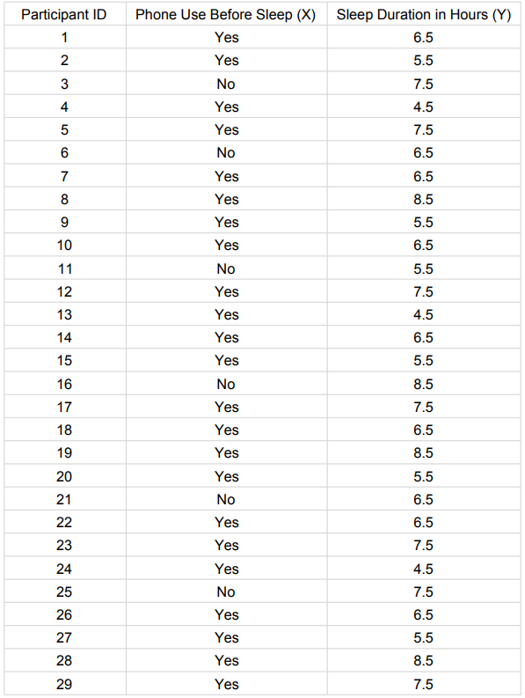
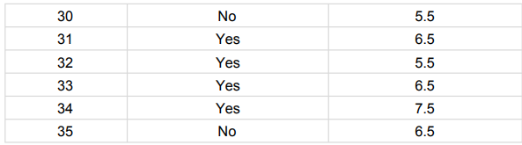
4.2. Brief description
A total of 35 valid responses were collected. Among them, 27 participants reported using their phones before sleep, while 8 participants did not. Preliminary summary shows that the average sleep duration for participants who used their phones before sleep was approximately 6.5 hours, while those who did not use their phones had an average of about 6.8 hours. 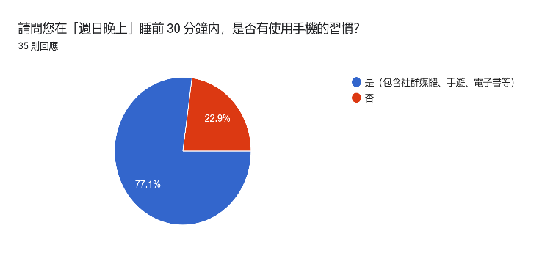
Fig. 1. Distribution of phone use before sleep.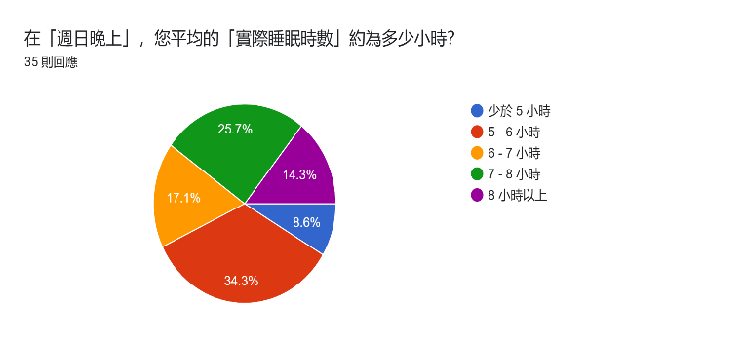
Fig. 2. Distribution of sleep duration.

Method Selection
5.1. Planned statistical method
The planned statistical method for this study is Welch's two-sample t-test.
5.2. Short justification
We selected Welch's two-sample t-test because our study compares the mean of a numerical response variable (sleep duration) between two independent categorical groups (phone users vs. non-users). Furthermore, Welch's t-test does not assume equal variances between the two groups, making it a more robust and suitable choice for our survey data.

